1. Do hands on with sample bash scripting 2. Print System information & how long it is up using script 3. create 10 files at a time with the name (1, 2, ...10).txt 4. Create a Global variable & print using Script. 5. list the files with the content "Congratulations

1: Do hands on with sample bash scripting

Vi script.sh

Script input

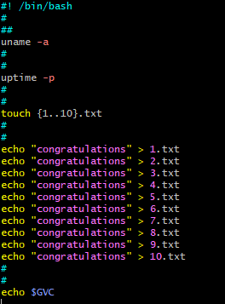

2: Print System information & how long it is up using

Command🡺 uname -a

Command🡺 uptime -p

3: create 10 files at a time with the name (1, 2, ...10).txt 4

Command🡺 touch {1..10}.txt

4: Create a Global variable & print using Script.

Command🡺 export gvc=200



Command🡺 echo $gvc

Script Output



5. list the files with the content "Congratulations

Command🡺 grep “congratulations” \*.txt

